**DEBT COLLECTION**

**Customers’ Best practices to fight against Fraud**

1. **Objectives**

Bring our P/H and customers’ expertise to help them decrease the number of fraudulent cases, hence reducing their potential loss.

1. **Debt collection definition of fraud**

**Swindling (fraud)** - acquisition, by deceit, of property of others or of a property right, avoidance or annulment of material obligation.

*Fraud definition divided into:*

***Confirmed fraud*** *– claim containing official documents confirming/proving fraud. (For example: written companies statement refusing debt based on fraud (if available, but not mandatory, including information about companies applications to police or any other legal steps started by company)).*

***Suspected fraud*** *- claim compatible to fraud warning signals, but not containing official documents. (No possibility to receive, or such does not exist)*

**Buyer:**

*fake identity – fake, not real company “created” by swindlers in order to cheat on creditors (all signs, like name, brand, website, contact information looks real, but such company does not exist);*

*de jure company – use of de jure active company/hopeless to make trading actions.*

*stolen identity – company’s name used fraudulently. Swindlers pretend themselves as representatives of active, known real company in order to cheat creditors;*

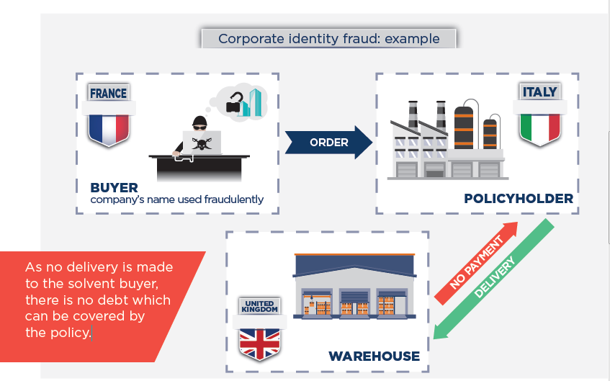

1. **How to detect a fraud?**

What questions to ask yourself before entering into a commercial relationship? Doesn’t it seem so good that it cannot be true? It will almost always be a fraud.

*\*more information in case study examples*.

**Tips for Customer:**

* **Order conditions** – if the price of offered goods is much lower than market average **– be careful!**
* **Pressure –** If you feel pressure from your partner to make a deal in a short time – **be careful!**
* **Language –** If your business partner use “broken” English and uses such phrases like “my friend”, “oh, I cannot believe”, “please trust me” – **be careful!**
* **Payment conditions –** if you are asked to pay into different account or different company – **be careful!**
* **Transport conditions –** if you are asked to deliver goods to other address or even country – **be careful!**
* **Ask –** if you have any suspicious, do not hesitate asking your business partner a lot of questions and details.
* **Apply to Coface –** if you need expert consultation, do not hesitate to ask Coface – **it may help to avoid fraud!**

**Please click the picture below to see an example:**

****

1. **Practical suggestions on how to protect yourselves against frauds**

Fraud detection and prevention may look a very difficult process, but using some part of this information/tutorial every company may take some steps so as to reduce possibility of frauds.

Below is some more detailed advice concerning prevention of frauds. It is even possible to use for the implementation/creation of internal company processes of fraud prevention:

**SWINDLERS ARE SMART... BE SMARTER!!!** 

① **Check the order thoroughly**

**BE SMART!** click picture to see what details should be paid attention to when checking the order



② **Match information** from debtor’s website with that of the public space.

**BE SMART!** Contact data could mismatch.

③ **Pay attention to**

• whether the company is not associated with the bankrupt/wound up business,

• whether the responsible person is not associated with the bankrupt/wound up business,

• whether the person who contacted you is not a cinema/sports celebrity.

**BE SMART!** Brad Pitt will not be looking to buy used tyres ☺

④ **Email**

• Pay special attention to the email address domain.

• A serious company will not use domains as @microsoft.com, @apple.com or free email accounts like yahoo, Gmail & Hotmail addresses

• Copy the domain of the email address to your browser and check the webpage on the internet.

• Check the email headers to find out in which country the email server is located.

• A company operating in Germany generally does not use email servers of an African state or China.

**BE SMART!** Use free emails “headers” checker on internet

⑤ **Company’s website on the internet**.

Check if the contact data matches the data provided in the public space. Quite often frauds use particulars of a real company and change just the telephone numbers. Be sure to pay attention to other aspects of the website:

• Structure and contents of the website: when constructing a scam website, frauds aim at creating the first impression, while the rest of the information contained in pages other than the home page is scanty.

• Website creation date: generally, websites created by frauds are new, have been online for a short period and it is not possible to find information about the owner of the website.

• Origin of photographs: check in the search system, where and how the photographs presented in the website are used.

**BE SMART!** C:\Users\mindaugas_puodziukas\AppData\Local\Microsoft\Windows\Temporary Internet Files\Content.IE5\88VIY1OQ\316px-Hand_1.svg[1].pngSwindlers will never invest into web quality.

C:\Users\mindaugas_puodziukas\AppData\Local\Microsoft\Windows\Temporary Internet Files\Content.IE5\88VIY1OQ\316px-Hand_1.svg[1].png Use free “Who.is” domain checker on internet.

C:\Users\mindaugas_puodziukas\AppData\Local\Microsoft\Windows\Temporary Internet Files\Content.IE5\88VIY1OQ\316px-Hand_1.svg[1].png We can always check photo origin with our browsers.

**⑥** **Credit reports**.

If you got interested in cooperation with the potential partner, be sure to apply to companies providing credit reports. There, you will see the legal status, sphere of activities and financial indicators of the company.

**BE SMART!** Apply to Coface!

**⑦ Pre-payment**.

Before preparing the goods for shipment, ask for a partial payment.

**BE SMART!** Fraudsters will not pay you, and will embark on a marathon of prevarications and promises.

**⑧ Check-up call**.

Call other telephone numbers than those indicated in the email, contract or website. Try to find the telephone number of other employees of the company on the internet and call them. It may turn out that nobody in the company knows the author of the offer.

**BE SMART!** One call cheaper when your possible loss.

At that moment such information might not prove relevant to you and you might not have enough time to deal with it. However, you should remember that you are the only one who can protect your business against possible losses.

All the provided information are advice and recommendation and if one of the items matches, this does not yet mean that you have encountered a dishonest customer. The more information you have, the more clearly you will see the picture and the more opportunities you will have to protect your business.

1. **How should you deal with your case if you have detected a fraud?**

If fraud was detected in the order phase (your company did not incur any loss yet):

* Stop cooperating with swindlers immediately.
* Contact the police
* Inform the real company which identity was being stolen and cooperate with it if needed on the bases of your law system.

If fraud detected after trading is made (your company incurred a loss):

* Inform police office about fraud immediately.
* Try to keep contacts with swindlers if it is possible.
* If the buyer was an insured company, notify Coface immediately.

1. **How is Coface going to handle your case?**

* A Notification of Overdue Account (NOA) must be registered as usual
* Then, your case will be transferred to the Debt Collect department to check the situation and get all possible information about the case.
* You will be instructed by Coface case handler what information and documents are required from you.
* All further actions, steps and decisions will be made under the conditions of your insurance policy, bearing in mind that frauds are not covered as per your policy terms.